







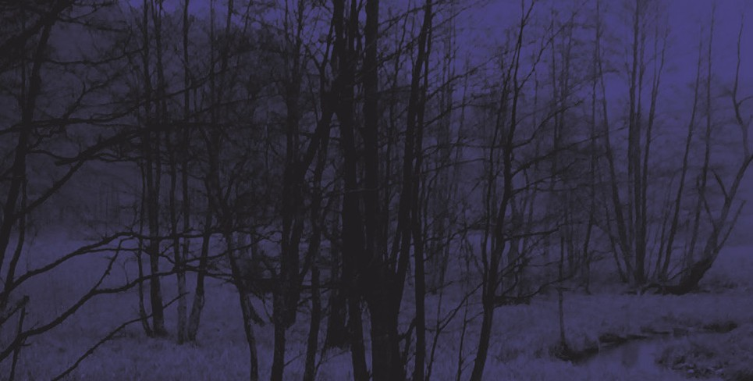

Annan Water
By Kate Thompson
Student Workbook


Annan Water Workbook Published by

Professional Development Service for Teachers (PDST)
Junior Certificate School Programme
Blackrock Education Centre, Kill Avenue, Dún Laoghaire, Co. Dublin
Phone: 01 2365000
Email: jcsp@pdst.ie

First Published 2012

Copyright ©PDST, JCSP.
The Professional Development Service for Teachers (PDST), The Junior Certificate School Programme (JCSP), the Literacy and Numeracy Strategy, the Demonstration Library Project and the Delivering Equality of Opportunity in Schools (DEIS) Action Plan are funded by the Teacher Education Section of the Department of Education and Skills (DES).

All rights reserved

The purpose of this publication is to enhance teaching and learning within the Junior Certificate School Programme.

No part of this publication may be reproduced, stored in a retrieval system or transmitted in any form or by any means for commercial gain without prior written permission of the publisher.

Every effort has been made to ensure that this book contains accurate information. However, PDST, JCSP, its agents and the authors shall not be liable for any loss or damage suffered by readers as a result of any information contained herein.

Written and shared by Heather Tennant, Librarian, JCSP Demonstration Library Project

Novel Resources Coordinated by Denise O’Flanagan, JCSP Advisor and Kathleen Moran, Senior Project Librarian, JCSP Demonstration Library Project

SUPPORTING WEB BASED MATERIAL

Kate Thompson’s book is inspired by
a folk song Annan Water she heard sung in Kinvara, Co. Galway.

The book is based in Scotland.
The river Uisge Annan is in southern Scotland, in the Dumfries region.

http://www.lyricsmania.com/annan_waters_lyrics_kate_rusby.html http://www.youtube.com/watch?v=joj4BqEfhis http://en.wikipedia.org/wiki/River_Annan http://i1.trekearth.com/photos/40387/img_9304hoddamwillowte.jpg
http://www.glaswegian.info/Images-of-Scotland/images/Images-of-Scotland---River-Annan-in- autumn-splendour.jpg

http://www.applebytown.talktalkbusiness.net/events/horsefair.pdf

Cover of the Book
You can’t judge a book by its cover – or can you?
The cover of “Annan Water” can give you some information about the book.

Look at the front cover first.

On looking at the illustration on the front cover of the book what do you think the book is about?

Now look at the back cover of Annan Water. What will it tell you?

Read the blurb on the back of the book. What do you think is going to happen in this book?

Do you think this book would appeal to boys, girls or both? Why do you think this?

Publishing information

The author of Annan Water is:

Annan Water was published by:

The book was published in the year:

The place the book was published:

Also:

Number of pages in Annan Water:

Is there and index, glossary etc:

3-2-1
Michael and his family have recently moved to Scotland. What does the book tell you about this move?

- Write three things you found out about the move
- Two interesting things you noticed about the move
- One question you still have about the move

3 | Things I found out
2 | Interesting things
1 | Question I still have

Focus on character
Who do you think is the main character?

Why do you think this is?

Name three other characters in ‘Annan Water’:

Describe what Michael looks like:

Describe what Annie looks like:

Read the description of Annie’s room and Michael’s room. What are the differences between the two rooms?

What adjectives would you use to describe their rooms that also reflect their characters?

Michael’s room | Annie’s room

Character traits
Use the graphic organiser below to show the ways that Michael and Annie are alike and the ways in which they are different. Write the ways they are alike or the characteristics they share in the intersection of the two sets.

MICHAEL ANNIE



Plot Development

What happens when Annie wants to brush Bandit?

What is blocking the chimney and how do Michael and Annie clear it?

When Frank and Jean come into the kitchen what do they find?

How do the family feel as Annie is leaving?

What impact does Annie’s visit have on the family?

Annie and Michael went to town shopping
How did they get into town?

What did they buy first and what was it for?

What shop did they go to next?

What did they do when the book they wanted was not in the shop?

How did they spend the rest of their time in town?

What leads up to Michael crashing the lorry?
Fill in the five Ws chart below.

Who?
What?
When?
Where?
Why?

The story is nearing the conclusion from page 150.
Why is Frank arguing with Michael in this part of the story?

What does Annie tell Michael on the telephone?

Describe Michael’s journey from his house to the shore of the river.

Write down three emotions Michael is feeling.

The conclusion

Whose help does Michael first look for to get across the river?

How does Bandit influence Michael’s decision to cross the river?

When he is in the water, what does Michael see that might save him?

How do the parents find out their children are missing?

What two things give them hope that Michael and Annie might still be alive?

FOR DISCUSSION
Read the ballad Annan Water and listen to it sung

http://www.youtube.com/watch?v=joj4BqEfhis

Do the book and the ballad have the same mood?

Does the book tell the same story as the ballad?

Were the snippets of the ballad throughout the book distracting or intriguing?

Write a text message conversation between Michael and Annie.

Michael
Annie
Michael
Annie
Michael
Annie
Michael
Annie
Michael
Annie
Michael
Annie
Michael

Write a postcard that Michael might have sent to his parents at the end of the story.
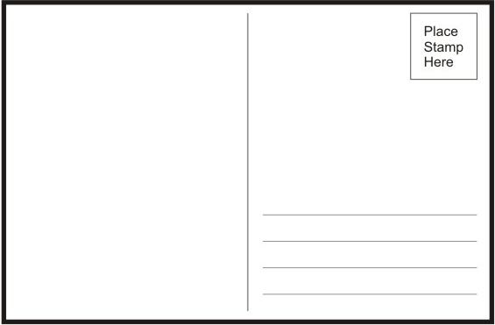

Write what you know about the death of Michael’s sister from reading the novel.

The Five Ws

Who?
What?
When?
Where?
Why?

Focus on the horses

Describe the two horses Michael takes down the green track. What are they called?

Number 1

Number 2

Why does Michael not like riding the mare?

How does he feel when he has to ride the mare?

What happened when the boy came to buy a horse and rode the mare?

What happened to the bay pony after the boy bought her?

What does Michael do to calm the bay pony?

How did the bay pony respond when it was her turn to jump?

When you have read Annan Water read the blurb at the back of the book again. How does it describe the book?

Write a new blurb, describing the book in your own words.

Vocabulary
Write down definitions of the following words that appear in this book. Use a dictionary to help you.

Word 1  Illicit | Definition
Word 2  Silage | Definition
Word 3  Placid | Definition
Word 4  Summon | Definition
Word 5  Paddock | Definition
Word 6  Poultice | Definition
Word 7  Disqualified | Definition
Word 8  Tenacious | Definition

Draw a picture of a scene from the end of the book where Michael and Bandit are in Annan Water
or
Draw a new front cover for the book.

Create a Story Pyramid

Story Pyramid

1.
Name of main character

2.
Two words describing main character

3.
Three words describing the setting

4.
Four words describing one event

5.
Five words describing a second event

6.
Six words describing how the novel ended

Word Search
‘Annan Water’

X | E | Y | C | X | Q | S | H | P | L | J | H | Q | R | F
S | N | N | B | J | I | G | X | E | A | E | Y | K | O | E
L | U | W | O | L | O | O | D | C | M | D | O | G | I | U
R | Y | O | A | M | B | Z | N | I | I | F | D | N | A | Y
J | I | G | I | E | M | V | Z | T | C | V | N | O | N | E
T | E | V | S | C | H | U | F | L | H | A | K | L | C | E
R | O | O | E | Q | A | F | S | U | A | C | Y | T | J | K
O | O | C | U | R | V | N | M | O | E | R | J | G | B | V
L | D | I | C | A | L | P | E | P | L | U | Z | F | M | N
I | L | L | I | C | I | T | V | T | R | J | T | B | V | G
Z | O | P | K | R | K | H | O | R | S | E | I | L | B | K
D | E | I | F | I | L | A | U | Q | S | I | D | J | F | U
I | O | C | A | X | C | W | T | D | Q | B | N | E | B | M
V | Y | O | Q | U | L | J | K | Z | J | I | A | X | P | K
W | J | G | Q | V | U | D | N | M | B | D | B | T | S | Y

ANNIE BANDIT
DISQUALIFIED HORSE
ILLICIT LOOSEBOX
MICHAEL PADDOCK
PLACID POULTICE
RIVER SILAGE
SUMMON TENACIOUS

Create a Story Map for Annan Water

Story Map

Main Character Setting

Supporting Character
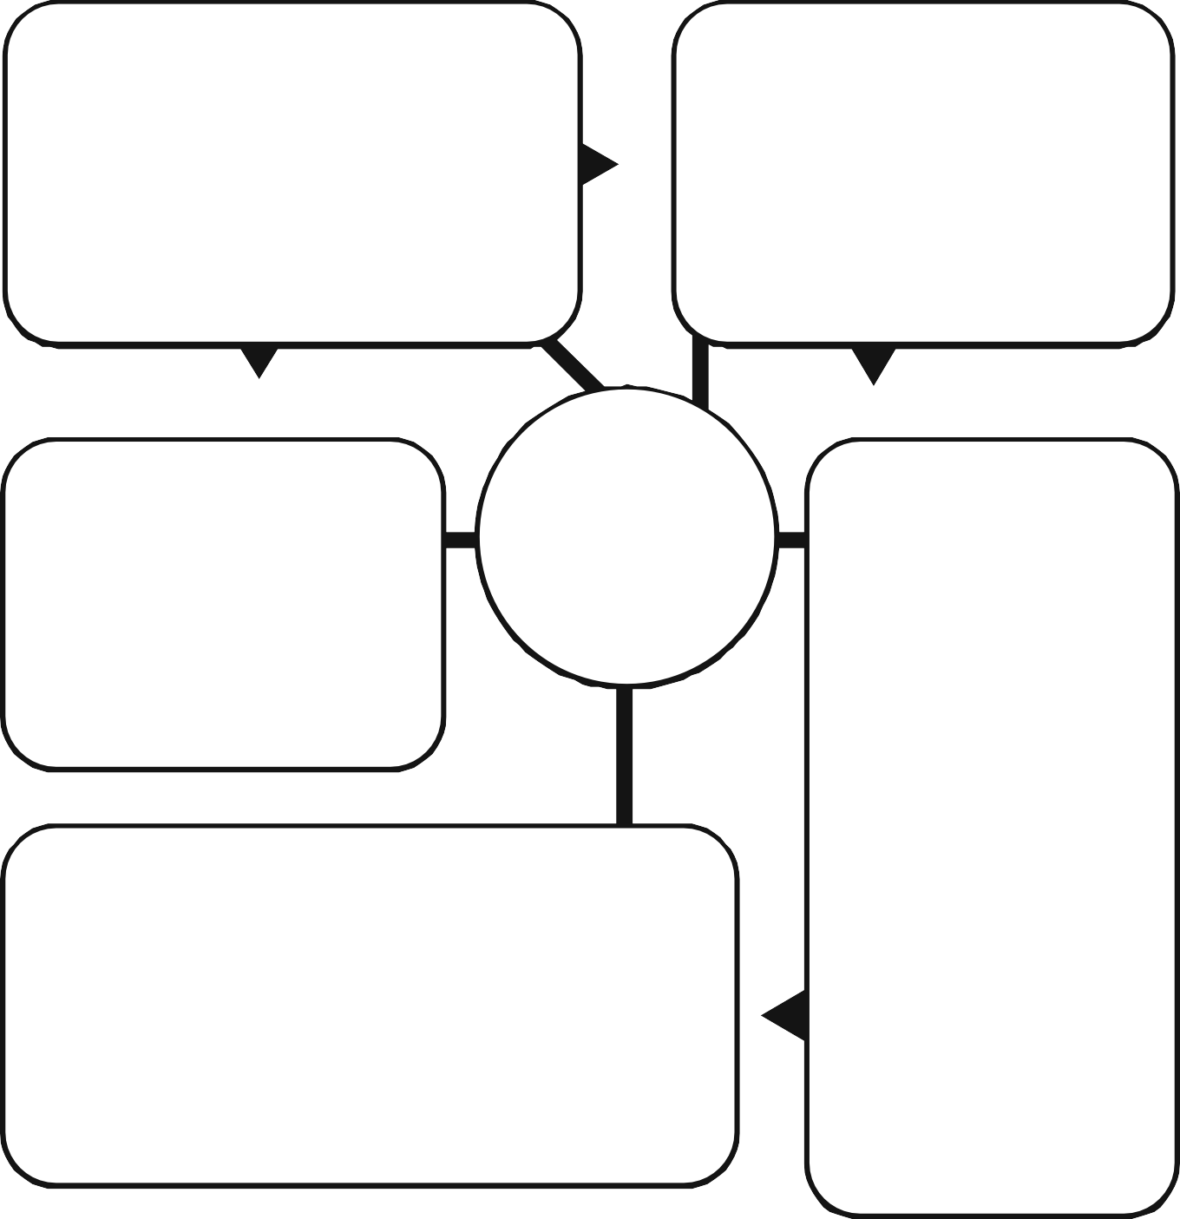

Title and Author
Problem

Solution

Plot Development
Introduction How does the story start?

Build-up/Development What happens next?

ClimaxWhat’s the most exciting part of the story?

Conclusion/Resolution What happens in the end?

Research
Search the internet to see if the author has a website. Be careful as there are two authors with the same name living in Ireland!

Find out three interesting facts about the author.

1

2

3

Name three other books written by the author.

1

2

3

From the author’s biography what do you think is her inspiration for this book?

What award did Annan Water win and in what year?

What book and author won this award most recently?

Find out

What is a New Zealand rug?

How does a poultice work?

What is a bridle?

What does a Loosebox look like?

What is MS (Multiple Sclerosis)?

Where is Dumfries in Scotland?

